Could you help lead the NHS in your area?
Hounslow and Richmond Community Healthcare NHS Trust and Kingston Hospital NHS Foundation Trust
Non-executive Director in Common x2
Candidate information pack
Reference: L2733

We value and promote diversity and are committed to equality of opportunity for all and appointments made on merit. We believe that the best boards are those that reflect the communities they serve.
We particularly welcome applications from women, people from the local black and minority ethnic communities, and disabled people who we know are underrepresented in chair and non-executive roles.
Our recruitment processes are conducted in accordance with the Code of Governance to ensure that they are made on merit after a fair and open process so that the best people, from the widest possible pool of candidates, are appointed.

Contents
Welcome from the Chair in Common 4
The Opportunity 6
The Person Specification 7
About the Trusts 9
London Leadership Values 13
Appendix 1: More Information
Appendix 2: Making an Application
Appendix 3: Key Dates

Dear Candidate

Thank you for your interest in becoming a non-executive director across our two high performing NHS trusts, Hounslow and Richmond Community Healthcare NHS Trust (HRCH) and Kingston Hospital NHS Foundation Trust (KHFT).

These are important and exciting new leadership appointments for us at a time of great opportunity, and I am delighted that you are exploring an application.

For some time now across HRCH and KHFT, we have been working together in close partnership. Although we remain as two separate organisations, since last year, there has been a Chair in Common, and Jo Farrar is Chief Executive of both Trusts. In April we brought the executive teams of the Trusts together into a single leadership team.

We have recently also established a Board Committee in Common, which oversees joint decision-making, and the Committee met in public for the first time in October 2022. Recently we appointed two non-executive directors in common. Our aim is to engage the full potential of community and acute resources at local level, in order to overcome health inequalities and, where appropriate, provide health and care closer to people’s homes.

We are now seeking two further exceptional individuals with the personal reputation and professional credentials to contribute to the leadership of the Trusts. We would like one non-executive director to lead on finance and productivity and the other on primary health care. Both roles take over from outstanding individuals who are coming to the end of their terms.

These are unique roles working across both North West London and South West London integrated care systems. The successful candidates will join us on the journey to deliver joined up care for our communities working closely with borough and other local partners. We have the potential to be truly innovative in our approach.

We are progressive and pioneering and given our scale, reach, and leadership of place based working, have the capability to deliver genuine service transformation.

You won’t be surprised to know how diverse our teams are across both Trusts. Our staff survey for example shows that around 35% of staff have black, Asian or minority ethnic backgrounds. We aim to embed diversity, equality and inclusion in our approach and expect all Board members to champion and promote equity. We particularly welcome applications from individuals who identify with any of the protected characteristics as we believe greater diversity enriches the quality of Board decision-making and provides role models for staff who reflect their lived experiences.

I hope that this pack will give you all the information you require but please do not hesitate to contact Odgers Berndtson if you need any further information. We look forward very much to hearing from you.

Sukhvinder Kaur-Stubbs

Chair of Hounslow and Richmond Community Healthcare NHS Trust and Kingston Hospital NHS Foundation Trust.



The Opportunity
This is an unique opportunity to share your talents and expertise to make a positive difference across acute and community services and to deliver outstanding care to the local population. The post-holders will be Non-executive Directors (NED) of the Trust Boards at both Hounslow and Richmond Community Healthcare NHS Trust (HRCH) and Kingston Hospital NHS Foundation Trust (KHFT).
For some time now HRCH and KHFT have been working closely together. In April 2022, Sukhvinder Kaur-Stubbs was appointed Chair in Common to achieve greater alignment between the two organisations. The Trusts also have a single executive team that works across both organisations and has already established two NED in common roles. It is expected that the journey to collaborate further in the interest of patients will continue to develop.
Places and place-based partnerships are to become a key feature of the planning and delivery of integrated health and care services. Whilst national guidance has set out broad parameters within which Places are expected to develop, there will be no national blueprint for their design. The core aims are:
- Better health – improving population health and wellbeing and reducing health inequalities
- Better care – providing consistently high-quality services, better outcomes, and patient experience
- Sustainability – maximising the use of Place-based resources
- Workforce – creating an environment for motivated, happy staff

HRCH and KHFT are already moving in this direction of travel.
Both HRCH & KHFT are high performing trusts and best in class for quality and staff experiences as evidenced in staff and patient surveys, as well as performance targets and awards.
HRCH and KHFT experiences during the Covid-19 pandemic have demonstrated the importance and benefits of system and Place-based working and the resilience and outcomes that can be achieved through a co-ordinated sharing of objectives, a pooling of resources, and a sense of common purpose.

Roles and responsibilities of the NED in Common
NEDs in common (NEDiC) will work alongside other NEDiCs, Associate NEDs in Common (ANEDiC), single trust NEDs and executive directors as an equal member of both unitary Boards (HRCH and KHFT). They will share responsibility with the other directors for the decisions made by the Boards and/or Committee in Common (CiC), and for the success of each sovereign organisation (and collectively) in leading the local delivery and improvement of healthcare services for patients.

Primary Health Care NEDiC
The NEDiC leading on Primary Health Care will champion, as a non-executive, the development of strategy across in the primary care sector and link both Trusts to achieve this together. There will be an opportunity to inspire and support executives leading place-based partnerships and in developing relevant connections with GPs, pharmacies, community and social services and other local services. The role will also lead on gaining assurances of plans, related implementations, and outcomes for primary health care activities undertaken by either or both Trusts.

Finance NEDiC
The NEDiC leading Finance will champion, as a non-executive, the development and delivery of strategy for all finance matters at both Trusts, and those undertaken collaboratively. The role will also lead on gaining assurance of all finance matters and productivity, as managed by the executive, to ensure plans are fully formed, implemented and that outcomes support the Trusts’ other objectives by delivering good financial outcomes. The NEDiC for finance will also chair the finance committee in common between both trusts.

The Person Specification
The NHS is founded on principles and values that bind together the diverse communities and people it serves – patients and public – and the staff who work for it.

Required values, competencies, skills and experience
NHS England are looking for candidates who want to use their energy, skills and experience to help drive the delivery of sustainable healthcare services for the local community.

Essential criteria
You will need to have a genuine commitment to patients and the promotion of excellent health care services. You will have experience in one of the following areas:
Primary Health Care NEDiC will have experience of leading or working within a primary care setting. The post holder would have senior level clinical and patient safety expertise gained from medical, nursing, allied disciplines, or social care experience at a senior level in an academic, research, regulatory or clinically focused role, and experience and knowledge of wider system working including STPs/ICSs and preferably a Clinician or GP. Knowledge of population health (and health inequalities) would also be desired.
Finance NEDiC will have experience of leading or working within a finance or accounting context at a senior level in non-executive and/or executive capacity. They will have relevant qualifications in finance related matters and be able to demonstrate undertesting of the related issues.

Values
All non-executive directors must champion the standards of public life – by upholding the highest standards of conduct and displaying the principles of selflessness, integrity, objectivity, accountability, openness, honesty, and leadership.
As a future NHS leader, the successful candidate will be able to demonstrate the range of behaviours required to contribute effectively in this board level role. These are outlined in the NHS Leadership Academy’s Healthcare Leadership Model.

Core competencies
You will work alongside other non-executives and executive colleagues as an equal member of the board. The Trust need diverse, inclusive and compassionate leaders who not only reflect the community they serve and the staff employed but have the leadership style and breadth of perspective to make good collective decisions. As an NHS leader, you will be able to demonstrate the five core competencies required to contribute effectively in the NHS non-executive director’s role. You will need to be able to demonstrate you can use your experience to:
- bring independence, external perspectives, skills and challenge to strategy development
- shape and support an inclusive, compassionate, person-centred culture for the trust, encouraging diversity, change and innovation
- close the gap on health inequalities, and achieve the service changes that are needed to improve population health
- use personal knowledge and experience to hold the executive to account by providing purposeful, constructive scrutiny and challenge
- achieve the best sustainable outcomes for patients and service users by encouraging continuous improvement, clinical excellence and value for money
- balance organisational governance priorities with system collaboration; prioritising population health in line with the NHS Long Term Plan.

Lived experience
Personally, you will bring a range of professional expertise as well as community understanding and experience to the work of the board. We are interested in your life experience and personal motivation that will add valuable personal insights such as: a patient or carer of a service user; experience of gender and women’s issues; engaging with diverse social, economic and cultural groups and communities; experiences and challenges of younger people; and those with lived experience of mental health issues and/or living with physical disability.

Time commitment and remuneration
The non-executive role is part-time to ensure independence and objectivity is maintained. The time commitment will therefore depend on local circumstances but should include attendance at all board meetings and board development sessions, some committee work and enough preparation time to ensure you are well briefed on internal and external context. A minimum of 3-4 days a month would be expected to undertake the role successfully.
The remuneration payable for these roles is £14,000.

Eligibility
Preference will be given to candidates who have a strong affinity and connections within the regional areas served by the trust and an understanding of the diverse communities it serves. Given the significant public profile and responsibility members of NHS boards hold, it is vital that those appointed inspire confidence of the public, patients and NHS staff at all times. As part of the assurance work for all board members under the fit and proper requirements, you will be asked to address questions relating to topics including misconduct or mismanagement, bankruptcy and convictions and we will make a number of specific background checks.

Improving diversity
We value and promote diversity and are committed to equality of opportunity for all. The best boards are those that reflect the communities we serve and therefore applications from all backgrounds are welcomed. We want to increase the diversity of our board and particularly encourage applications from women, people from the local Black Asian and Minority Ethnic communities, LGBT communities, younger candidates and from people with lived experience of disability, who we know are all

About Hounslow and Richmond Community Healthcare NHS Trust (HRCH)
HRCH provides community health services for around 523,000 people registered with GPs across the London boroughs of Hounslow and Richmond, but also serves a wider population across south west London for a range of more specialist community services.
Every day their professionals provide high-quality healthcare in people’s homes and convenient local clinics. They help people to stay well in the community, manage their own health with the right support and avoid stays in hospital.
They employ around 1,200 people (excluding contractors), who work across a wide range of health centres, hospitals, GP surgeries, children’s centres, schools, local council facilities and in community settings – including in people’s homes.
Their most recent CQC rating (October 2018) rated the trust as Good overall, and Good across all domains and services.
Our mission (what they are here for)
‘To provide outstanding care and services that we and our families would want to use.’
Our vision (what they aspire to be)
People will live healthier lives through high-quality, effective and co-ordinated care.
Our values (what is important to them)
Our set of core staff values were developed with our staff, key stakeholders and the local community across Hounslow and Richmond:
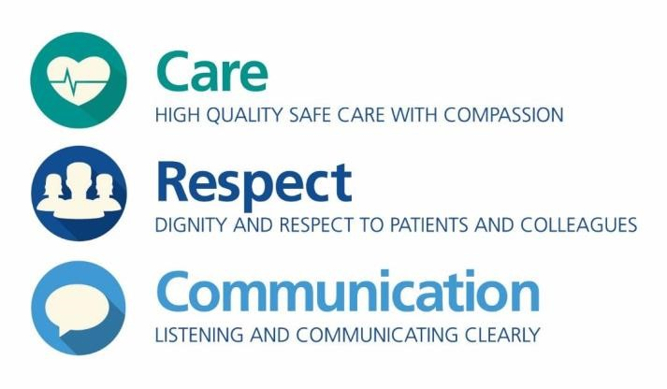

About Kingston Hospital NHS Foundation Trust (KHFT)
KHFT is a single site, medium sized hospital, located within Kingston-Upon-Thames in South West London. The Trust provides services to approximately 350,000 people locally. As well as delivering services from the main hospital base, the Trust delivers ambulatory services at a range of community locations such as in Raynes Park,
Surbiton, Queen Mary’s Roehampton and Teddington, in partnership with GPs and community providers.
KHFT was licensed as an NHS Foundation Trust with effect from 1 May 2013. An inspection by the Care Quality Commission was undertaken in summer 2018, resulting in an overall ‘Outstanding’ assessment for quality, caring and for well led.
KHFT has approximately 350 beds and directly employs around 2,900 staff with another 300 staff employed by contractors working on behalf of the Trust.
The Trust has strong links with tertiary and specialist hospitals, particularly St George’s University Hospitals NHS Foundation Trust. The Royal Marsden Hospital NHS Foundation Trust jointly provides cancer services with KHFT on the Kingston Hospital site in the Sir William Rous Unit. KHFT also has close links with Kingston University, St George's Medical School and with Chelsea & Westminster Hospital NHS Foundation Trust. They jointly run the Elective Orthopaedic Centre at Epsom Hospital in partnership with St George’s, Croydon and Epsom & St Helier Hospitals. They are also a partner in South West London Pathology, a partnership set up with Croydon Health Services NHS Trust and St George's to provide a single, integrated pathology service across South West London and beyond.
KHFT provides a full range of diagnostic and treatment services and has a national reputation for innovative developments in healthcare, particularly in ‘patient-focused’ care across their services including emergency, day surgery and maternity services.
The Trust is also an active partner in the acute collaborative partnership that operates across the four Trusts of SW London. It is undertaking work on both back office and clinical support services to increase efficiency and reduce cost and is also commencing work on clinical standardisation and a review of elective services. As a member of the West London Cancer Vanguard, work is focused on developing high quality services across all providers and commissioners in West London (RM
Partners).
The Trust is recognised as being relatively lean and efficient with low reference costs and the lowest Adjusted Treatment Cost according to the Lord Carter productivity review.

Vision and values
Since 2011, KHFT has been working to a set of core values developed by staff and patients to enable the organisation to deliver the shared vision of ‘working together to deliver exceptional, compassionate care – each and every time’. They aim to make these values – ‘caring, safe, responsible, and value each other - what we do for every patient, every colleague,’ every day.
- Caring: Design and deliver care around each individual patient’s needs and wants
- Safe: Make the safety of patients and staff our prime concern (safety comes first)
- Responsible: All staff take responsibility for the hospital, its services and reputation
- Value Each Other: We all value each other’s contribution
- Inspiring: We always strive to empower each other to develop and deliver improvements to benefit our patients

Strategic objectives
In 2022, through an extensive engagement exercise a set of common objectives were agreed across HRCH and Kingston Hospital. They are summarised as below.
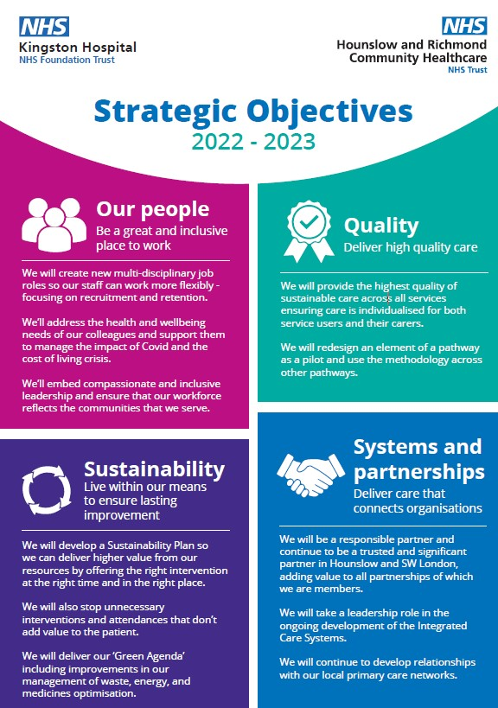

London Leadership Values

Core values
Our core values right now are:
- Courage, passion and decisiveness
- Compassion (which we define as being open, fair, generous, enabling and responsive)
- Integrity (behaving with consistency and doing what we say)

Aspirational values
Over the next 12 months we would also like to demonstrate that we are:
- Consistently hard on the problems but generous with people
This will mean we are supportive and selfless and show respect to one another in public and in private
- Effortlessly inclusive

Accidental values and behaviours
The most common or most destructive accidental behaviours/values that we see in the system right now and which we would like to eradicate include:
- Putting institutions and staff ahead of patients and citizens
- Using power to obstruct or for ‘gaming’, point scoring, personal attacks and bullying
- Using information and knowledge as a ‘bargaining chip’ or to shame colleagues instead of sharing information openly and creating opportunities to learn
- Failing to be open and honest not saying things ‘in the room’
- Learned helplessness and ‘playing safe’
Alongside honesty and integrity, we expect leaders in the London NHS to be:
- Working collaboratively, and
- Taking accountability for the mandate

Appendix 1: More Information
For information about the trust, such as business plans, annual reports, and services, visit Home :: Hounslow & Richmond Community Healthcare (hrch.nhs.uk) and Home Page - Kingston Hospital. Follow the links for more information about:
- Support to prepare candidates to apply for a non-executive vacancy including:
- Building your application
- Sources of information and useful reading
- Eligibility and disqualification criteria
- Terms and conditions of chair and non-executive director appointments
- How we will handle your application and information

• View all current chair and non-executive vacancies • Sign up to receive email alerts on the latest vacancies • Contact details for the Non-executive Appointments Team

NHS England respects your privacy and is committed to protecting your personal data. We will only use personal data where we have your consent or where we need to comply with a legal or statutory obligation. It is important that you read this information together with our privacy notice so that you are fully aware of how and why we are using your data.

Appendix 2: Making an Application
If you wish to be considered for this role please provide:
- a CV that includes your address and contact details, highlighting and explaining any gaps in your employment history
- a supporting statement that highlights your motivation for applying and your understanding of the NHS and the role. You should outline your personal responsibility and achievement within previous roles and how your experience matches the person specification
- the names, positions, organisations and contact details for three referees. Your referees should be individuals in a line management capacity, and cover your most recent employer, any regulated health or social care activity or where roles involved children or vulnerable adults. Your references may be taken prior to interview and may be shared with the selection panel
- please complete and return the monitoring information form which accompanies this pack and is available for download
- tell us about any dates when you will not be available
Appendix 3: Key Dates

• Closing date for receipt of applications: 9 December 2022 at 11am. Please forward your completed application to england.chairsandneds@nhs.net
- Preliminary interviews: longlisted candidates will be invited to attend preliminary interviews with Odgers Berndtson during December 2022. Feedback from these interviews will be given to the panel
- Stakeholder event: the shortlisted candidates will be invited to the Trust to meet groups of its key stakeholders during January 2023

• Interview date: 27th January 2023
• Final appointments will be made for HRCH via NHSE’s Appointments and Approvals Sub-Committee (London) and KHFT through their own Council of
Governors (CoG) Remuneration Committee during February 2023

• Proposed start date: 1 April 2023 Getting in touch
- We strongly recommend an informal and confidential discussion with Sukhvinder Kaur-Stubbs, the Chair of the trusts. Please contact Louise Burkill on 020 8973 3132.
- Odgers Berndtson is helping us to identify potential candidates, if you would like a confidential discussion about the role contact Carmel Gibbons or Ruth Lewis on 020 7529 6314, or at carmel.gibbons@odgersberndtson.com / ruth.lewis@odgersberndtson.com.
- NHS England – for general enquiries contact Miriam Walker on 0113 825 0009 or by emailing miriam.walker@nhs.net

NHS England
E: england.chairsandneds@nhs.net
W: england.nhs.uk

